Activity Recognition in Dense Sensor Networks

James Howard
William Hoff
Colorado School of Mines
{jahoward, whoff}@mines.edu

The problem of building security is a very old and extensively studied problem. Everything from complex locking mechanisms to motion sensors are meant to ensure intruders do not enter a building without cause, but what about the case when people are supposed to be there? What mechanisms are in place to ensure the safety and security of the building when it is open to the public? Due to the need for security cameras to be actively watching during an attack, they rarely play a proactive role in security and are instead typically used for criminal forensic analysis after a crime has been committed. In cases of public spaces, how do we ensure an adequate level of security? Current implementations of security systems in public spaces are quite often inadequate.

Take for instance the Minneapolis skyway, a climate-controlled pedestrian walkway connecting the buildings of downtown Minneapolis at the second or third floors. The walkway is over seven miles in length and covers nearly 80 city blocks. Security in this system is the responsibility of each building connected to the skyway, which typically comes in the form of a security guard who shares his time behind a desk watching security cameras and patrolling the hallways.

Given its public access, high popularity and its connection to almost every major building in Minneapolis, any would-be attacker against the city of Minneapolis could use this infrastructure. Criminals or terrorists would likely spy on targeted buildings, determining the best avenue for attack. How is a security guard, given the limited amount of resources available to him, able to discern such surreptitious spying?
To solve such a problem, we propose a system using low-cost sensors and wireless motes to monitor large spaces, often containing a large number of people, and providing feedback about the activities within that space. Our system is not limited to buildings, and could be applied to external public spaces such as sidewalks or open markets where manual analysis of threats may be impossible due to the sheer size or timescale required for proper threat determination. Nor is our system limited to discovering actions such as spying in the form of loitering. The proposed system should be capable of discovering any anomalous activity such as riots, fires, and perhaps even muggings or heart attacks. We view the system as something used by a security guard in addition to typical security cameras. We presume the probability of a guard watching a certain camera at the time of interest is low and thus we propose a system that would alert the guard to a potential problem letting the guard determine the threat and the appropriate response.

We believe the market is ripe for exactly this type of security need. Consider that since September 11, 2001, under the direction of the then Federal Bureau of Investigation Director Robert Mueller, the Joint Terrorism Task Force (JTTF) has grown from 35 field offices to 100 and has an annual operating budget of $6.4 billion. The increase in size of the JTTF has primarily been to increase the probability of attacks prevented and not to increase the efficacy of our response. Because of this increase it is clear that domestic terrorism security is of paramount importance to the United States. Given its possibility as a preventative measure, our proposed system fills a need not currently covered by any existing security system. We look to local cities and the United States Government as potential customers.

Existing work:
Automatic recognition of activities using computer vision methods is being intensively studied, but is currently in the research stage. Instead, the state of the art is to require humans to watch video feeds to detect activities of interest. To cover large areas with videos cameras however, is cost prohibitive. While the cost of typical security cameras is only 40 to 60 dollars [1], the cost of monitoring them is considerably more. A typical security guard, who makes on average $30, 000 annually can watch approximately 15 monitors at time. Meaning that the yearly operating cost for a camera is about $2,000. While our system does not propose to remove any security cameras, we do think it possible for a guard to watch hundreds of cameras at once by having the system alert the guard to any anomalous behavior.

Consider too the legal ramifications of a camera-based monitoring system for public spaces. Due to privacy issues, any automated security system that uses a video-first approach to security may improperly be applying privacy law because a determination could be made of the where abouts of an individual without the required probable cause (or in the case of terrorism related cases, reasonable suspicion). Take for example the case of automated traffic cameras. Based on the possibility that they may be used by law enforcement to determine the location of people in public spaces without proper legal authority, the American Civil Liberties Union has expressed public concern, possibly leading to a legal case. Already it is necessary for traffic cameras to blur passengers in vehicles found in violation of traffic law. To avoid the necessity of waiting for jurisprudence to consider the outcome of such a case, we believe an anonymous sensor-first approach offers a better technical and privacy respecting solution.

There are a limited number of research laboratories [2, 3, 4] working on similar activity recognition problems using a sensor-first approach, but they appear not to focus on the same large area data sets that we do. Much of the existing research in activity classification either deals with a small number of people, a limited area, short tracking duration, or exclusively uses video for its content. Also much of the existing work requires a large amount of human interaction and intuition about the environment to perform the proper real time situational analysis.

Our Approach:
Due to the potential for human error and to reduce setup time, we look to implement a system that dynamically determines the topology of our environment. We then use the topological information to discover local spatial neighborhoods around each sensor. These spatial neighborhoods are then used to create local patterns of activity which can be used to determine anomalies. Finally, we analyze the distribution of these local patterns to highlight changes in activity patterns.

Experimental Testbed:
Using the Colorado School of Mines Brown Building as our testbed, we placed 10 small wireless computers (motes) and 50 passive infrared motion detector sensors though out the second floor (Figure 1). This location provides a good experimental test bed as it contains offices, class rooms and research laboratories. Data is sampled every second across the network and transmitted to a central database. Because data is so simple compared to traditional video, years' worth of data may be recorded and stored on a relatively inexpensive computer compared to the expensive storage methods required for video surveillance.

With the remainder of our Lockheed Martin funding (which ended in January 2009), 30 additional motes and 100 additional sensors were purchased, with the intent to expand the network to the third floor. The extra data collected from this expansion is expected to give us a better idea of how different environments affect motion. Plans are also in place to experiment with different types of sensors (sound, sonar, break beam, light, etc) to determine the affect sensed data has on our algorithm.
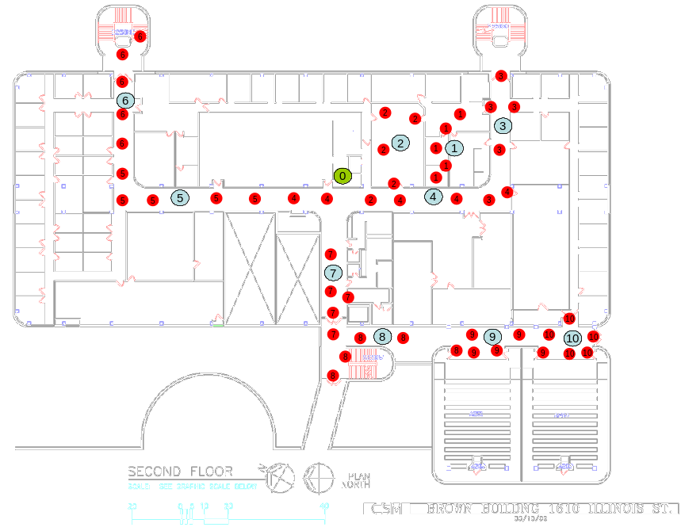Figure 1: Mote and sensor locations. Red points represent sensors, blue points the computers, and the green point a base station.

Determining Local Neighborhoods:
As stated before, because we seek to keep our system with as little human setup cost as possible, we propose determining the global sensor topology automatically. To do this we use Gabriel Graphs [5] based on the inverse cross correlation score derived from the sensor activations (Figure 2). Not only does this approach yield a graph which allows for the creation of local neighborhoods, but it can lead to insights into the sensed environment that are not readily apparent and may be overlooked by human designation of sensor neighborhoods.

Consider figure 2, which shows a sensor topology derived from a single day of readings. Notice how most of the spatially close sensors are also neighbors in this activation space. There are a few notable exceptions. The link from sensor number 44 to sensor number 84, for example, does not seem intuitive. Indeed it may not have an obvious explanation, but it is plausible that this link exists due to both sensors being about the same relative distance from a major classroom. Both rooms may have been on similar classroom schedules, thus leading to this strong correlation.

Of course this relationship between 44 and 84 will only be valid in instances where classrooms are letting out. For a given time of day the network topology will certainly change. By allowing this change, we increase the networks capability to handle local variances in the environment.

Determining Local Activity:
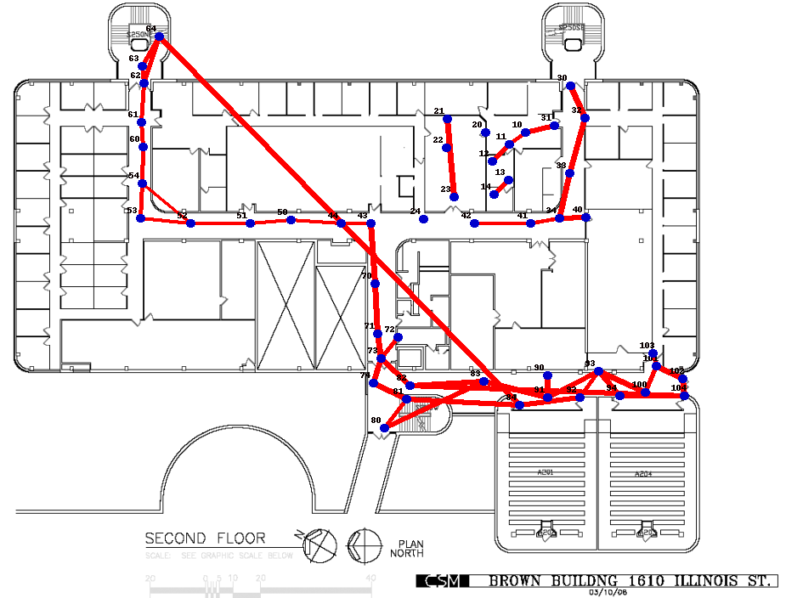Figure 2: Gabriel Graph using cross-correlation scores
Given our sensor topology, we can then begin to define local activities around individual sensors. To calculate these local activities we implement a Hidden Markov Model (HMM) based clustering algorithm. Using the likelihood that a local activity was generated by a given HMM as a basis to determine our error function, we implement a simulated annealing style approach to calculate the set of HMM's that best represent our data. Activities are represented by a matrix as shown in figure 3. The x axis of the matrix represents the neighborhood of sensors and the y axis time. A blue pixel represents activity while a black pixel indicates no motion was detected. All activities shown in figure 3 are assigned to a different HMM and are representative of the types of activities described by the model.
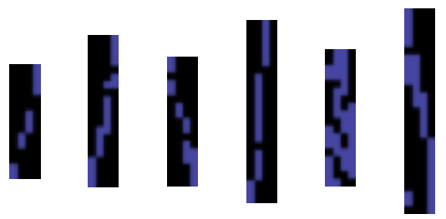Figure 3: Common activities calculated by different Hidden Markov Models

Determining Context:
Returning to the Minneapolis skyway scenario, clearly there are going to be spatial variations in activity. These variations should be captured by our per-sensor local activity representation. For example, it makes sense that people will loiter longer in food court locations than in front of an office building. Extending this to the temporal domain, it should also come as no surprise that people will loiter longer during certain times of the day than at others. Behavior and environment are not independent variables and within an environment time and space are important when determining what is anomalous and what isn't.

Our system implements a probabilistic latent semantic analysis [6] of the distribution of local activities to determine when these temporal changes occur. We then use this information to create a set of latent classes which each become experts at a description of a different part of our data. An example of this approach is given in Figure 4 which was made with data split for each day of the week and trained using 8 latent classes. From figure 4 it can be seen that for the problem of determining action for a given day of the week, latent class 2 and latent class 4 seem to form a distinct set of clusters for determining the day of the week. Points in the upper right quadrant of the graph tend to represent weekdays while points in the lower left represent weekends.
Figure 4: Latent class 2 vs Latent class 4.

Notice that the red circled point is a Sunday, but has clustered with only weekday points. We reference this point to be anomalous and flag it for further analysis. Looking at the raw data for this day shows that there was a large gathering in the atrium that afternoon. This is a brief example showing how our system has the capability to discover anomalies.

Although the system is still in flux and many of the automated features we envision are not yet implemented, we believe the system with additional work could assist the United States in becoming a more secure nation will still maintaining the absolute privacy of every citizen.

References:
1. Super Circuits Security Cameras, http://www.supercircuits.com/Security-Cameras/
2. S. S. Intille and A.F. Bobick, “Recognizing Planned Multiperson Action,” Computer Vision and Image Understanding, pp. 414 – 445, 2001.
3. S. Gong and T. Xiang, “Recognition of Group Activities using Dynamic Probabilistic Networks,” Proc. of the Ninth IEEE International Conference on Computer Vision (ICCV 03), 2003.
4. Wren, C.R. and Tapia, E.M., “Toward scalable activity recognition for sensor networks,” Proc. of Second International Workshop on Location and Context Awareness (Springer-Verlag Lecture Notes in Computer Science Vol.3987), pp. 168 -185.
5. Gabriel, K.R. and Skokal, “A new statistical approach to geographic variation analysis,” Systematic Zoology, 1969.
6. Hofmann, T., “Probabilistic Latent Semantic Indexing,” Proc. of the Twenty-Second Annual International SIGIR Conference on Research and Development in Information Retrieval, 1999.

None of the above work is bound by any intellectual property protection.

